## Report on

**Joy Of Programming Using Python**

## Submitted For Summer Internship Program

## By

## Rohit Tomar

## (CS,1900270120046)

## Under The Guidance Of

## Dr. Pratima Singh

## Mr. Binayak Parashar



## AJAY KUMAR GARG ENGINEERING COLLEGE, GHAZIABAD

## YEAR 2020-2021

Index

|  |  |
| --- | --- |
| **1** | **Project 12** |
| **2** | **Assignment 14** |
| **3** | **Assignment 24** |
| **4** | **Assignment 3** |

Project-12

What’s the Word

This game focuses on the user having to guess the randomly generated word. Player has to rearrange the characters of the word to make a correct meaningful word. There is a hint button. User can use 3 Hints. User can also pick a different word.

## Input Format

User can only type alphabetical words.

## Output Format

The output of the game is Correct or Wrong based on the user’s input.

## Example

|  |  |  |  |
| --- | --- | --- | --- |
|  | **Given Word** | **Input** | **Output** |
| **Example 1** | **oLuts** | **Lotus** | **Correct** |
| **Example 2** | **esRo** | **Roes** | **Incorrect** |

## Sample Test Cases

|  |  |  |  |
| --- | --- | --- | --- |
|  | **Given Word** | **Input** | **Output** |
| **Test Case 1** | **hrcdiO** | **Orchid** | **Correct** |
| **Test Case 2** | **annaaB** | **Banana** | **Correct** |
| **Test Case 3** | **iJasenm** | **Jaisemn** | **Wrong** |
| **Test Case 4** | **eppAl** | **Apple** | **Correct** |
| **Test Case 5** | **iwKi** | **Kiwi** | **Correct** |
| **Test Case 6** | **aMogn** | **Mango** | **Correct** |
| **Test Case 7** | **ePnoy** | **Peont** | **Wrong** |
| **Test Case 8** | **eByulebrr** | **Blurbeery** | **Wrong** |

Solution:-

## Screenshot 2020-07-04 at 3.39.57 PM.png

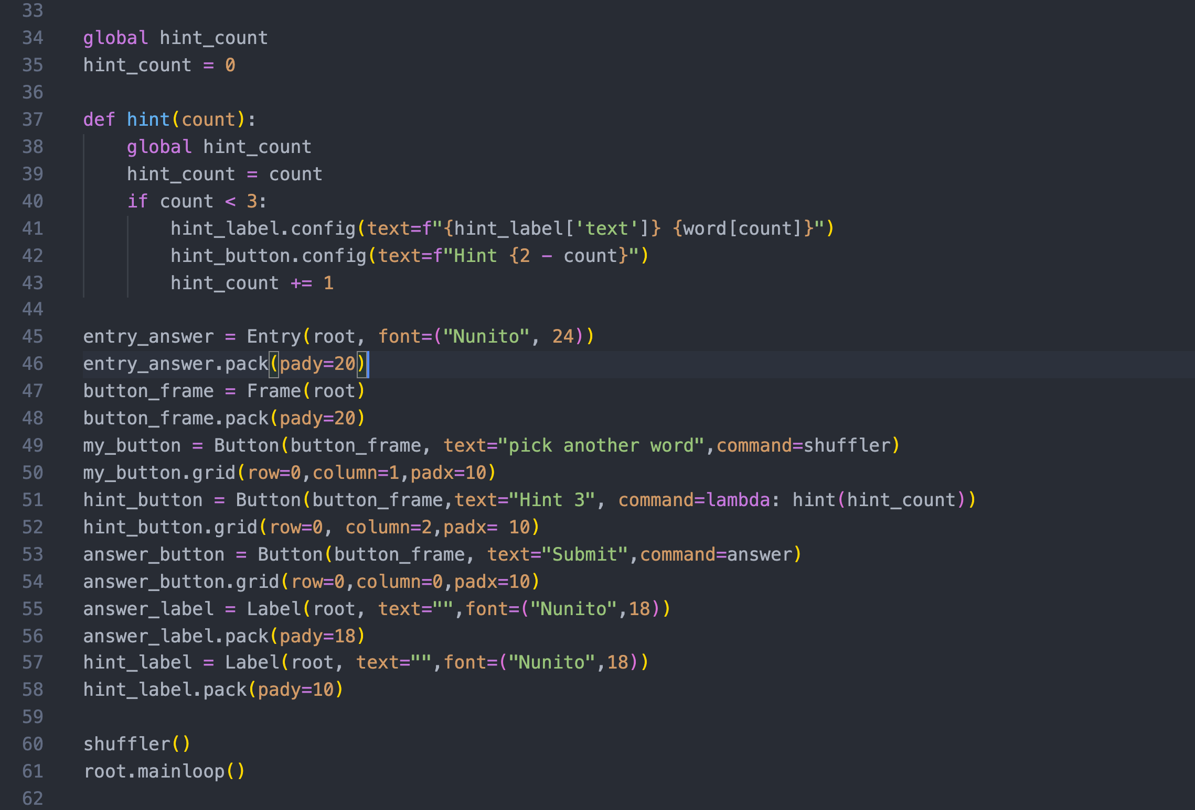

**Test Case 1:**

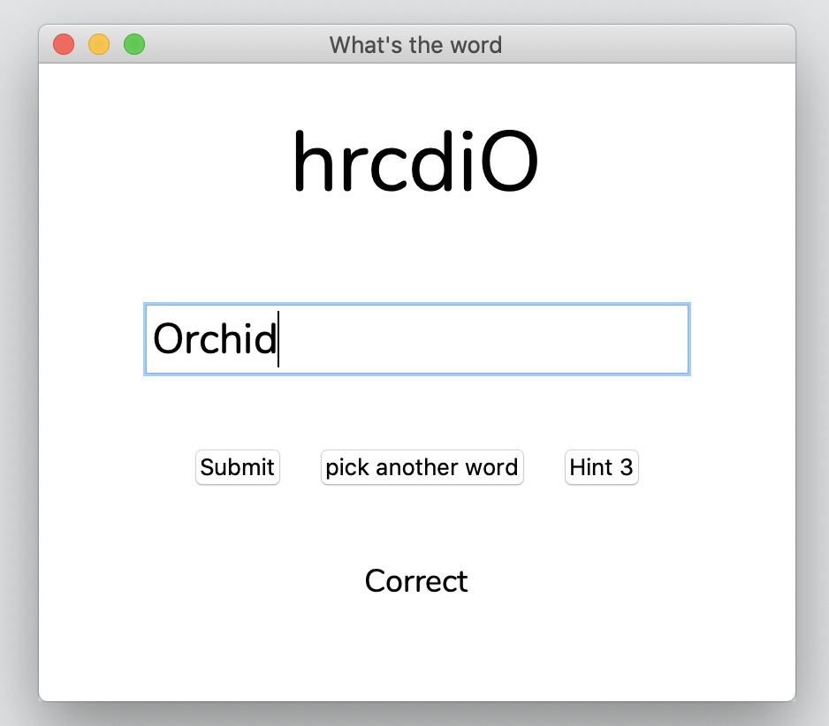

**Test Case 2:**

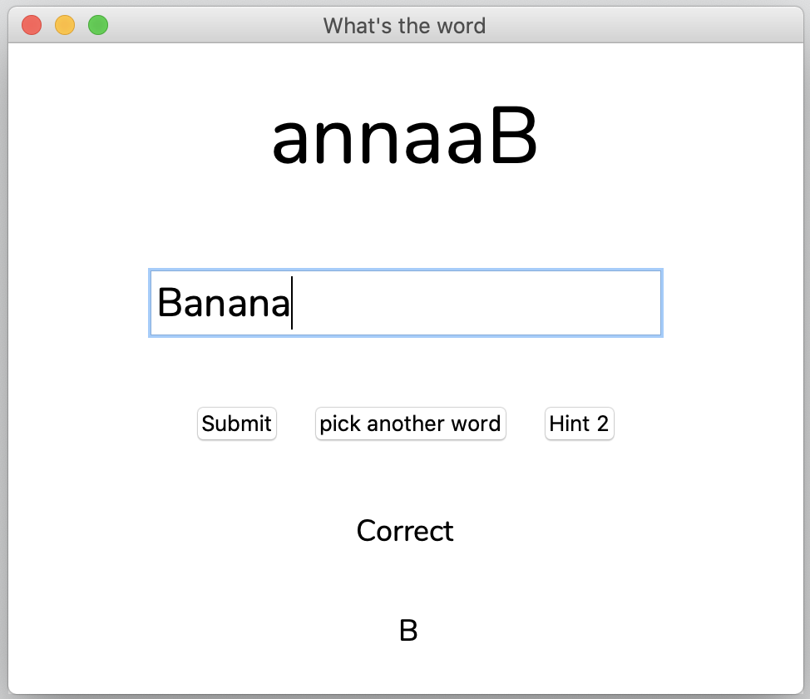

**Test Case 3:**

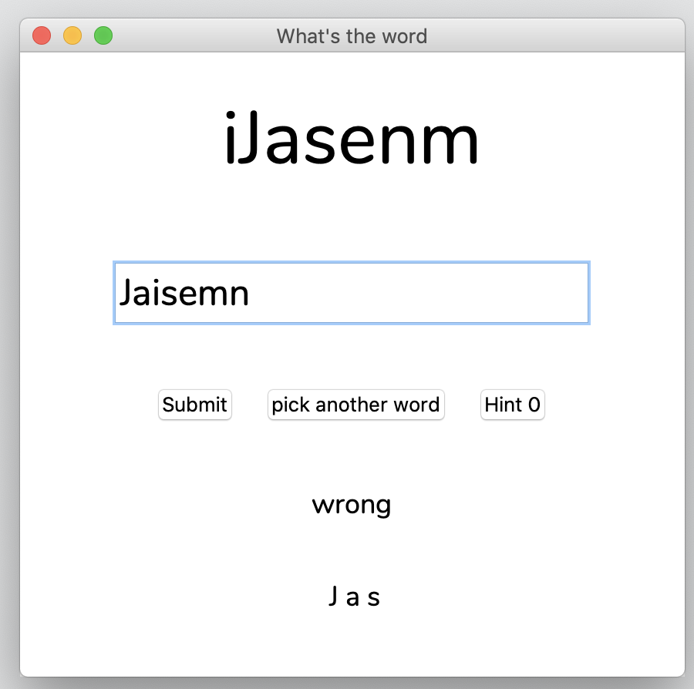

**Test Case 4:**

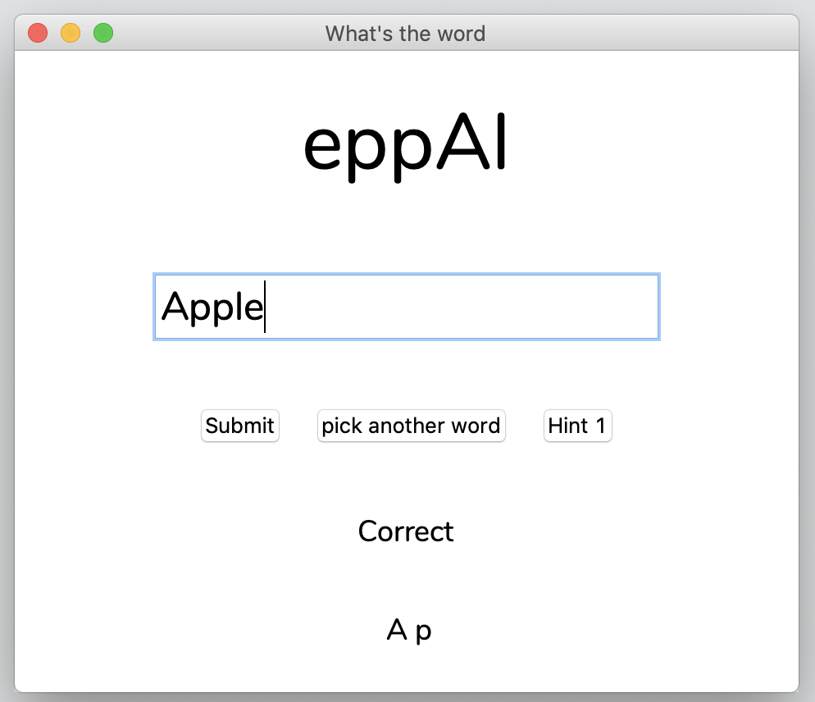

**Test Case 5:**

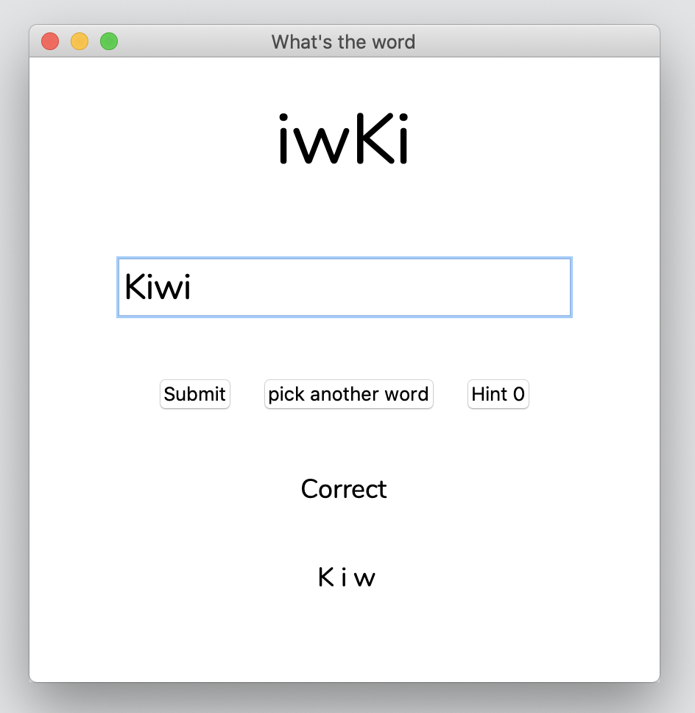

**Test Case 6:**

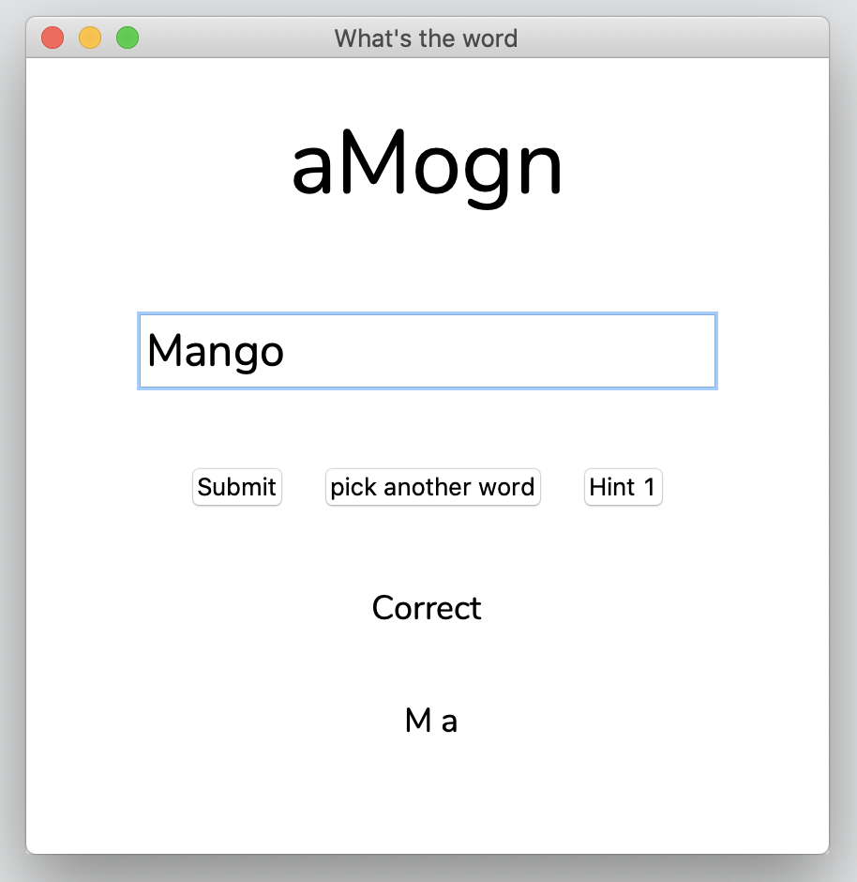

**Test Case 7:**

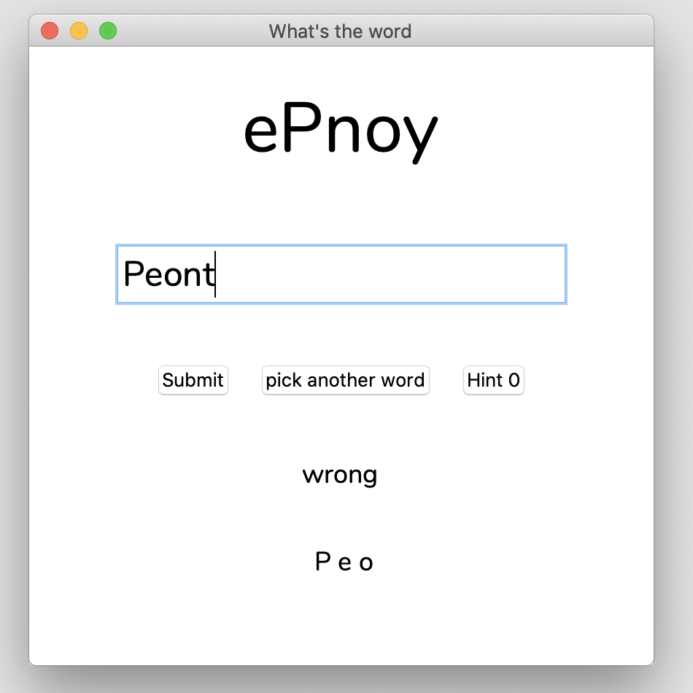

**Test Case 8:**

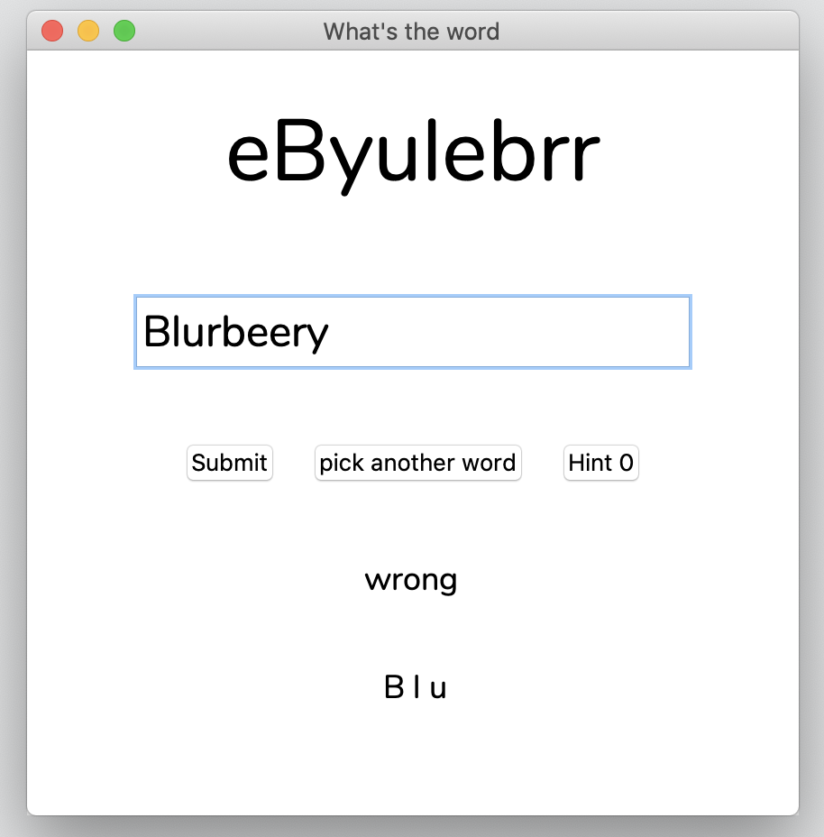

**Assignment 14**

**Q.** Write a Python program to count the even, odd numbers in a given array of integers using Lambda.

**Code:-**

## 

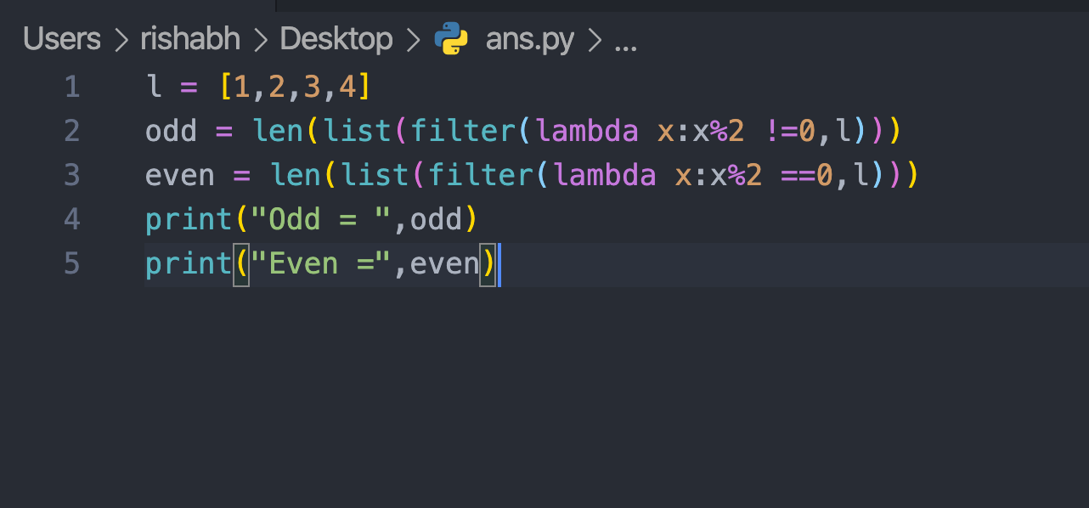

**Test Case:-**

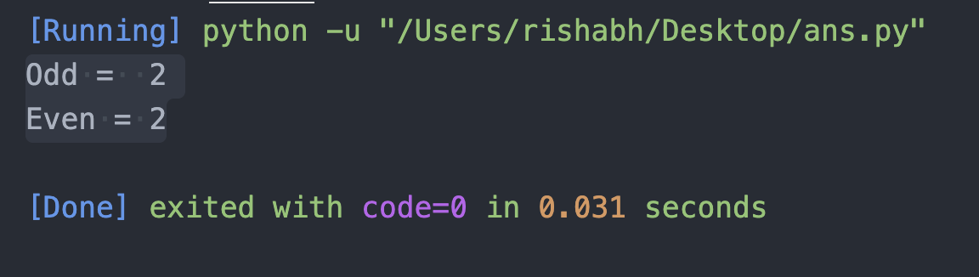

**Assignment 24**

**Q.** Write a Python function that takes a list of words and returns the length of the longest one.

## Code:-

## Screenshot 2020-07-07 at 4.38.08 PM.png

**Test Case:-**

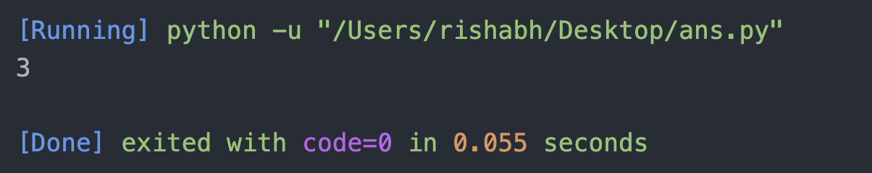

Assignment 3

**Q.** Write a Python function that takes two lists and returns True if they have at least one common member.

## 

## Code:-

## 

## 

## Screenshot 2020-07-07 at 4.40.44 PM.png

## 

## 

## Test Case:-

## Screenshot 2020-07-07 at 4.40.49 PM.png